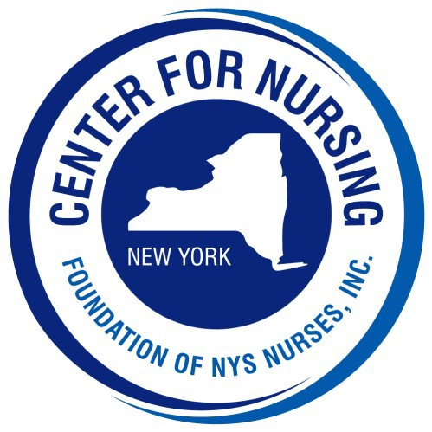
2024 Nightingale Gala
Tickets and Tables of 10
Call (518) 456-7858, ext. 129 for more information

o $175 per person o $105 Young Professional (35 & Under) o $1,500 Table of 10

Name:
Address: City: State: NY Zip: Telephone #: Email:
Check Enclosed (made payable to Foundation of NYS Nurses, Inc.)
Please charge my credit card: Card # Exp: CVV:

Names of Guests: _______________________________________________________________________
For Tables of 10 please indicate all names of guests and meal choices on back of form
Please indicate each guest’s meal selection & number of meals
o Flank Steak / number of meals _______
o Chicken Bruschetta /number of meals _______
o Grilled Salmon (GF) /number of meals________
o Eggplant Napoleon (V) number of meals_______

PLEASE REPLY by SEPTEMBER 3, 2024

Please return this form with your payment to:
Center for Nursing at the Foundation of NYS Nurses, Inc., 2113 Western Avenue, Guilderland, NY 12084 Telephone (518) 456-7858 Fax (518)452-3760 Email: delliott@cfnny.org

Tables of 10 Names and Meal Choices of Guests

Name Meal Choice

