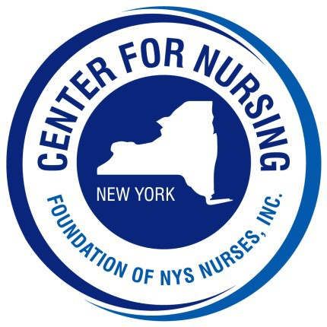
2024 Nightingale Gala
Program Ad Form
Call (518) 456-7858, ext. 129 for more information

Place an ad honoring:
The 2024 awardees, an exemplary nurse or to promote your business

Ad Deadline: Friday, August 23, 2024

1/4 Page
2.25” x 3.75”
$75

1/2 Page
4.75” x 3.75”
$125

Full Page
4.75” x 7.75”
$250
Inside Cover
(Front / Back)
$500
Back Cover
(Outside)
$650

Please check one:
[ ] Please use same ad as last year [ ] Copy of ad is enclosed [ ] Prepare copy for us *

Organization / Business: Contact: Address: City: State: Zip: Telephone #: Email:
Check Enclosed (made payable to Foundation of NYS Nurses, Inc.)
Please charge my credit card: Card # Exp: C VV:

Please return this form with your payment to:
Center for Nursing at the Foundation of NYS Nurses, Inc., 2113 Western Avenue, Guilderland, NY 12084 Telephone (518) 456-7858 Fax (518) 452-3760
Prepared ads can be emailed to Deb at delliott@cfnny.org

* Additional fee will be charged to create ad copy

