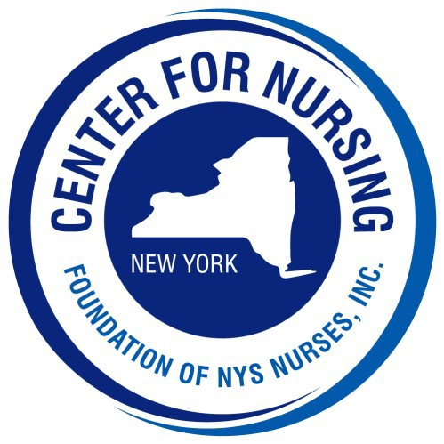
2024 Nightingale Gala

Sponsorship Form

[ ] Innovator* | $10,000 | - Includes two (2) tables of ten (10) and centerfold program ad
[ ] Crafter | $ 5,000 | - Includes one table of ten (10) and full page program ad
[ ] Photography Sponsor* | $ 3,000 | - Includes six (6) tickets and full page program ad
[ ] Music Sponsor* | $ 2,000 | - Includes four (4) tickets and full page program ad
[ ] Cultivator | $ 1,500 | - Includes four (4) tickets and half page program ad
[ ] Curator | $ 500 | - Includes two (2) tickets and quarter page program ad

*These sponsorship levels are exclusive to one organization/business/individual
In order to be noted on the invitation, listed in the program, and recognized at the event, Sponsors must be submitted by July 1, 2024
Please check your sponsorship level above

Organization / Business: Contact: same
Address: . City: State: NY Zip: Telephone #: Email:
Check Enclosed (made payable to Foundation of NYS Nurses, Inc.)
Please charge my credit card: Card # Exp: CVV:

Please return this form with your payment to:
Center for Nursing at the Foundation of NYS Nurses, Inc., 2113 Western Avenue, Guilderland, NY 12084 Telephone (518) 456-7858 Fax (518) 452-3760 Email: delliott@cfnny.org

Meal Choices of Guests
(20 guests for Innovator, 10 guests for Crafter, 6 guests for Photography, 4 guests for Music and Cultivator, 2 guests for Curator)

Name Meal Choice

