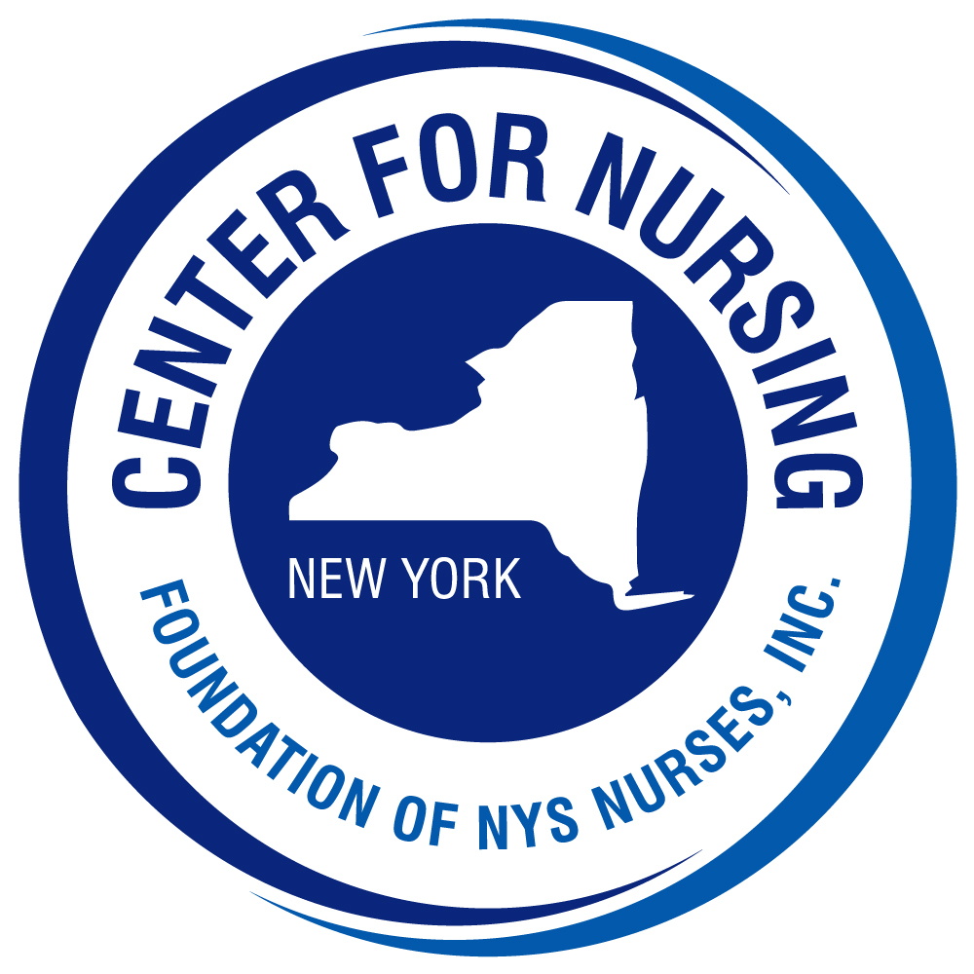



February 2025

Dear Colleagues,

Since 1980, the Foundation of New York State Nurses has sponsored a program to recognize nurse researchers who conduct studies that contribute to the advancement of nursing and patient care. This program fulfills the Strategic Plan goal of the Cathryne A. Welch Center for Nursing Research to recognize outstanding nursing research in New York. Since its inception, thirty-four Distinguished Nurse Researchers (DNR) have been recognized. In 2008, the program was expanded to include recognition of a Novice Nurse Researcher (NNR). These scholars have created a legacy of leadership and scholarship which continues to inspire programs of nursing research.

In 2010, the Novice Nurse Researcher program was updated with new criteria and a new name – Rising Nurse Researcher. This packet reflects these changes. This year we have again revised the criteria to make them more realistic to the experience of early-career nurse researchers.

The accompanying packet provides you with the eligibility and nomination requirements for the Rising Nurse Researcher Award as well as an outline of the review criteria and process. If you have questions, please do not hesitate to contact me at the Foundation for clarification. We encourage you to nominate a colleague and to share this information with others whose work may qualify. We thank you for your consideration of the Award program and your interest in nursing research.

For your information I have attached the names of previous awardees.

Sincerely,

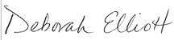

Deborah Elliott, MBA, BSN, RN
Executive Director
Center for Nursing
Foundation of New York State Nurses
2113 Western Ave.
Guilderland, NY 12084
(518) 456-7858 ext. 29
www.cfnny.org.

Previous Nursing Research Awardees

RISING NURSE RESEARCHERS
2019 Allison Norful, PhD, Rn, ANP-BC
2014 Marilyn J. Hammer, PhD, DC, RN
2011 Lorie Smith Goshin, PhD, MSN, RN
2009 Mary Rosedale, PhD, PMHNP-BC, NEA-BC
2008 Christina Koulouglioti, PhD, RN

DISTINGUISHED NURSE RESEARCHERS
2024 Sally Norton, PhD, FNAP, FPCN, FAAN
2017 Hyekyun Rhee, PhD, RN, PNP, FAAN
2015 Veronica Feeg, PhD, RN, FAAN
2013 Deborah A. Chyun, PhD, FAHA, FAAN
2011 Ann Kurth, PhD, CNM, FAAN
2010 Nancy M. Watson, PhD, RN, FGSA
2009 Gail D’Eramo Melkus, EdD, MS, ASN/BS
2008 Patricia W. Stone, PhD, RN
2007 Mary W. Byrne, PhD, RN, FAAN
2006 Carol S. Brewer, PhD, RN
2006 Hong Li, PhD, RN
2005 Keville C. Frederickson, EdD, RN, FAAN
2004 Dianne Morrison-Beedy, PhD, RNC, WHNP
2003 Joyce K. Anastasi, PhD, RN, FAAN, LAc
2002 Jean K. Brown, PhD, RN, FAAN
2001 Margaret Lunney, PhD, RN, CS
2000 Bernadette M. Melnyk, PhD, RN-CS, PNP
1999 Sandra Graham McClowry PhD, RN, FAAN
1998 Lillie M. Shortridge-Baggett, EdD, RN, FAAN
1997 Judith Gedney Baggs, PhD, RN
1996 Terry T. Fulmer, PhD, RN, FAAN
1995 Elizabeth A.M. Barrett, PhD, RN, FAAN
1994 Christine T. Kovner, PhD, RN, FAAN
1993 Kathleen B. King, PhD, RN
1992 Susan E. Pollack, PhD, RN, FAAN
1991 Bethel A. Powers, PhD, RN
1990 Ellen M. Baer, PhD, RN
1989 Thelma J. Wells, PhD, RN, FAAN, FRCN
1988 Madeline H. Schmitt, PhD, RN, FAAN
1987 Wanda C. Hiestand, EdD, RN
1986 Marlene Ventura, EdD, RN, FAAN
1983 Marilyn T. Oberst, EdD, RN
1982 Carol N. Hoskins, PhD, RN
1981 Jean E. Johnson, PhD, RN
1980 Judith A. Sullivan, EdD, RN

Foundation of New York State Nurses
Cathryne A. Welch Center for Nursing Research
2025 Rising Nurse Researcher Award
Nomination Packet
Nominate yourself or a colleague for the Foundation of New York State Nurses 2025 Rising Nurse Researcher Award
*****************************************************************************************
The Foundation of New York State Nurses Cathryne A. Welch Center for Nursing Research invites nominations, including self-nominations, for the Rising Nurse Researcher Award. This award, sponsored by the Foundation of New York State Nurses, is designed to recognize excellence in nursing research. Current members of the Foundation of New York State Nurses Center for Nursing Research and the Nursing Research Fellowship Program are ineligible to be nominated or to participate in the nomination process.

Definition of eligibility:

The Rising Nurse Researcher is a licensed, registered professional nurse in New York State who has completed a PhD or DNS within the past ten years and has obtained at least one degree, either baccalaureate or higher in nursing.

This person:
1. Presents a quality of research which has a clear conceptual basis, valid methods, and supported conclusions.
2. Demonstrates evidence of an emerging program of research relevant to the science and art of nursing and health care.
3. Disseminates findings to the scientific and clinical communities.
4. Has served as Principal Investigator.
5. Is involved in other research activities.

Please see the review sheet for evaluation criteria

Nominations and supporting documents, both hard copy and electronic, must be received by May 16, 2025

The Nomination Packet for the Rising Nurse Researcher Award consists of the following forms:
- Instructions for Nominators
- Nominator’s Form
- Instructions for Supporting References
- Nominee Instructions
- Nominee’s Personal Statement
6. Review sheet for award (for informational purposes only)
Foundation of New York State Nurses
Central New York Nurses Center for Nursing Research
2025 Rising Nurse Researcher Award

Instructions for the Nominator

- Secure the nominee’s permission to submit her/his name in nomination for the Rising Nurse Researcher Award.
- Complete and sign the Nominator’s Form.

- Give the nominee the Nominee Instructions and the Nominee Personal Statement Form for completion.

- Distribute Reference Forms to two (2) other individuals who are willing to sponsor this nomination.

5. A completed packet of one electronic copy with signatures should be submitted by May 16, 2025 to: Deborah Elliott delliott@cfnny.org

Note: the nomination is not complete until all forms of the application packet are received.

After the Nomination Packets are received, members of the Foundation of NYS Nurses Cathryne A.Welch Center for Nursing Research Awards Workgroup will review the nominees and submit their recommendation(s) for the 2025 Awardee to the Foundation of NYS Nurses Board of Directors. For additional information or questions please contact:
Deborah Elliott delliott@cfnny.org

Thank you for submitting this nomination!
THE FOUNDATION OF NEW YORK STATE NURSES
Center for Nursing Research
2025 Rising Nurse Researcher Award

Nominator’s Form

Name of Nominee____________________________________________________

- Using the five personal characteristics for this award, and the definition of eligibility, please state why you think the nominee (or self) should be considered for the Rising Nurse Researcher award. (Maximum 4 pages.)

- Please list the names, titles, and addresses of the two individuals providing references for this nominee (or self).

- Nominator’s Information

Signature_____________________________________________Date____________

Name_________________________________________________________________

Title/position__________________________________________________________________

Address_______________________________________________________________

______________________________________________________________________

______________________________________________________________________

Telephone (Please indicate preferred contact method)

Work ____________________________; Other________________________________

Email_________________________________________________

THE FOUNDATION OF NEW YORK STATE NURSES
Cathryne A. Welch Center for Nursing Research
2025 Rising Nurse Researcher Award

Instructions for Individuals Submitting References

Thank you for being willing to provide a reference for ____________________________
who has been nominated for the Foundation of New York State Nurses Rising Nurse Researcher Award. The personal characteristics of the Rising Nurse Researcher are:

1. Presents a quality of research which has a clear conceptual basis, valid methods, and supported conclusions.
2. Demonstrates evidence of an emerging program of research relevant to the science and art of nursing and health care.
3. Disseminates findings to the scientific and clinical communities.
4. Has served as Principal Investigator.
5. Is involved in other research activities.

Please comment, in 1-2 pages, on the significance of the nominee’s research contribution to nursing in light of the stated characteristics. Please sign and date this reference. The statement should be submitted by electronic copy by May 16,2025 to:
Deborah Elliott delliott@cfnny.org

For additional information about the Rising Nurse Researcher Award, please visit www.cfnny.org

Thank you for contributing to this nomination!

Foundation of New York State Nurses
Cathryne A. Welch Center for Nursing Research
2025 Rising Nurse Researcher Award

Nominee Instructions

Congratulations on your Nomination for the 2025 Rising Nurse Researcher Award! Nominees for the Rising Nurse Researcher Award, given biennially by the Foundation of New York State Nurses. For additional information about the Rising Nurse Researcher Award, please visit www.FoundationNYSNurses.org.
Characteristics of the Rising Nurse Researcher:

1. Presents a quality of research which has a clear conceptual basis, valid methods, and supported conclusions.
2. Demonstrates evidence of an emerging program of research relevant to the science and art of nursing and health care.
3. Disseminates findings to the scientific and clinical communities.
4. Has served as Principal Investigator.
5. Is involved in other research activities.

As a nominee, we request that you submit the following supporting documentation of your eligibility for the award:

- Complete and sign the attached Nominee’s Personal Statement Form;
- Submit reprints or copies of three (3) articles that are representative of the scope of your published research;
- Attach your curriculum vitae emphasizing your research

Please submit an electronic copy of the above documents by May 16, 2025 to Deborah Elliott delliott@cfnny.org

For questions, please contact: Deborah Elliott delliott@cfnny.org

Congratulations on your nomination!
THE FOUNDATION OF NEW YORK STATE NURSES
Cathryne A. Welch Center for Nursing Research
2025 Rising Nurse Researcher Award

NOMINEE’S PERSONAL STATEMENT

(Please limit to 5 pages)

1. I have been or am presently involved in the following research activities:

2. My major contributions to nursing knowledge and nursing research have been:

************************************************

By returning these materials, I accept the nomination for the Rising Nurse Researcher Award and grant the Foundation Center for Nursing Research the right to review these and all other materials pertaining to my nomination.

Signature________________________________________________Date__________

Name_________________________________________________________________

Mailing Address________________________________________________________

______________________________________________________________________

Telephone: (Please indicate preferred contact method)

Cell: _______________________________ Work:___________________________

E-mail Address__________________________________________________________

NYS RN License #_________________________________

THE FOUNDATION OF NEW YORK STATE NURSES
Cathryne A. Welch Center for Nursing Research Steering Committee
2025 Rising Nurse Researcher Award

CRITERIA FOR RISING NURSE RESEARCHER AWARD
For information only – do not complete

CRITERIA | EVIDENCE
1. Quality of Research  2. Evidence of an emerging program of research  3. Dissemination of research to scientific and clinical communities  4. Has served as Principal Investigator | 1. Clear conceptual basis  2. Valid methods  3. Supported conclusions  4. Adds to the body of knowledge  1. Related studies  2. Consistent pattern of inquiry  1. Published  a. Articles  1. Data based research  2. Theory development  3. Clinical application of research  4. Primary author  5. Co-author  b. Journals  1. Refereed  2. Editorial work  c. Books  1. Author and/or editorial work  2. Presentations  1. Regional  2. National  3. Posters  4. Podium presentations  5. Webinars  1. Has received funding for research  2. Served as principal investigator  3. Co-investigator
5. Involved in other research activities | 1. Served as facilitator, mentor, or consultant  2. Active in professional organizations

